

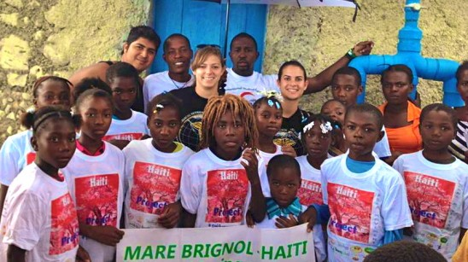Students Provide Nutrition, Hope in Haiti

After what seemed like a never-ending journey from airplane, to boat, to car, three UCF seniors on a mission trip to end malnutrition in Haiti were welcomed by children shouting, “Bon bagay isit,” which in Creole means, “Good things are here!”

As part of their involvement with International Medical Outreach, a registered student organization, Brittney Osterhoudt (biomedical sciences major), Cindy Toledo (social work major), and Cristhian Valor (biomedical sciences major) have dedicated three years of their lives to international medical outreach in various countries, and the past six months to increasing health and ending malnutrition in Haiti.  How? By introducing a plant that can supply all the nutrients needed in a well-balanced diet. It’s called moringa, and the group thinks it is the answer to many of the Haitian community’s health woes.

“It’s like growing vitamins in your backyard,” said Toledo. She brought the idea of introducing and expanding access to the plant in Haiti to the medical-outreach  group about six months ago after acquiring a sponsorship by BioPlanet International.

Every month since then, she has seen her vision for a self-sustaining project take root. “By the end of our last trip, the Haitian children were planting the moringa and taking charge. You give a sense of ownership to these kids and they take it to a whole new level!”

Moringa provides many essential vitamins and minerals. It can be eaten right off the plant, or dried and used as a spice or vitamin supplement. The parts of the plant that are usually not eaten, like the stems, are recommended to be fed to animals to increase their production and health.

“It’s like the tree of life, it gives hope to each person one leaf at a time,” said Toledo about the plant that is native to subtropical parts of Africa and Asia.

As far as nutrition goes, in a gram-for-gram comparison moringa is equivalent to four oranges (Vitamin C), four bananas (potassium), four carrots (Vitamin A), one egg (protein) and four servings of milk (calcium). It helps with hypertension, anemia, vaginal infections, malnutrition, improves eyesight and helps build strong bones. It has a slightly spicy taste.

“I’d compare it to a spicy spinach,” said Osterhoudt. “Some say it’s similar to arugula.”

It is a very hardy plant that grows in tough conditions. Up to 75 percent of its leaves can be taken and it still grows. Those who want to see this miracle plant first hand don’t have to go far. The UCF Arboretum has a few moringa plants.

“The UCF variety is actually spicier than the variety we tasted in Haiti,” said Valor.

During their trip, the group planted more than 100 trees and distributed more than 500 seeds in a community garden and at individual households. They left their gardening tools with community members so they can continue to cultivate and spread the plant. Valor and Osterhoudt plan to return in December and May respectively, to check on the plants.

All three students involved in the mission trips say that their involvement has impacted their decision on what to do with their lives after college. All plan to visit Haiti again in the coming months. Valor is even learning Creole, so he can communicate better with the people he meets. “I’ve seen the kids grow,” he said. “I’m not just there to help, but I’m their friend as well. As I continue to grow in my profession, I want to stay involved. I love these people.”

Osterhoudt said: “The best part of UCF is the opportunity you are given…I feel like IMO changed my life.”

For more information on International Medical Outreach, visit [www.imoucf.org](http://www.imoucf.org/).

